**UNIVERSITY OF ULSTER**

**FACULTY OF COMPUTING, ENGINEERING AND BUILT ENVIRONMENT**

**COURSEWORK SUBMISSION SHEET**

**This sheet must be completed in full and attached to the front of each item of assessment before submission to Module Coordinator/Instructor, Prof. KongFatt Wong-Lin, via Blackboard Learn**

Student’s Name: Adilah Afroze Khan

Registration No: B00992838

Course Title: Business Intelligence & Analytics

Module Code/Title ………COM735 / Business Intelligence & Analytics………

Lecturer ……………………Prof. KongFatt Wong-Lin……………………………..

Date Due ……………………17th April 2025………………………………….

(NB: Latest hand-in time is 9:05 pm on the due date unless otherwise advised)

**Submitted work is subject to the following assessment policies:**

1. Coursework must be submitted by the specified date.
2. Students may seek prior consent from the Course Director to submit coursework after the official deadline; such requests must be accompanied by a satisfactory explanation, and in the case of illness by a medical certificate.
3. Coursework submitted without consent after the deadline will not normally be accepted and will therefore receive a mark of zero.

*I declare that this is all my own work and that any material I have referred to has been accurately referenced and any contribution of Artificial Intelligence technology has been fully acknowledged. I have read the University’s policy on academic misconduct and understand the different forms of academic misconduct. If it is shown that material has been falsified, plagiarised, or I have otherwise attempted to obtain an unfair advantage for myself or others, I understand that I may face sanctions in accordance with the policies and procedures of the University. A mark of zero may be awarded and the reason for that mark will be recorded on my file.*

RTC trends to help insurance companies price and insure more accurately

Adilah Afroze Khan

***Abstract*— Road Traffic Collisions (RTCs) has been a long time priority of the government that have led to increased insurance premiums and safety concerns in Northern Ireland, and this study makes a foray into applying business intelligence techniques to study the possibility of finding trends in RTCs within a structured database provided by the Northern Ireland Police Service (PSNI). A Power BI dashboard was created to analyse RTC data under the following dimensions: weekdays, location, age, gender, and severity type. Several visual reports, such as matrix views, bar charts, and scatter plots, were created for analysing the association of these variables with accident severity. The visual analysis revealed that young male drivers, high-speed rural areas, and peak weekdays are the greatest contributors to severe collisions. Although these data are relatively static, they provide high interpretability and accessibility but enable actionable insight. Based on this, policy recommendations were made. The work thus suggests that public data and visual analytics tools can meaningfully inform road safety policies and equitable insurance practices.**

***Keywords:* Road Traffic Collisions, Power BI, Policy Making, Insurance, Data Visualisation, Northern Ireland**

# INTRODUCTION

Road safety remains a major issue in the world, with traffic-related injuries posing a great threat to both public health and the economy. This study analyses a large dataset of traffic accidents and uses visualisation to find out useful trends based on location, age group, severity, and weekdays. This will deliver results that will assist in policy and insurance decision-making.

# BACKGROUND STUDIES

Numerous studies have been done to showcase the importance of analytics in road safety improvements. Sweden’s ‘Vision Zero’ is a strategy to lower mortality, where predictive models have been used.[1] BI technologies are being widely used in smart cities to detect threats in real time.[2] Insurers are getting into adopting telematics and a behaviour-based pricing system.[3] Motivated by these approaches, this work imports their methodologies to build a unique condition of Northern Ireland. Big appreciation to these studies that helped to make proactive decisions in cases of road safety.

# METHODS

1. Data Description:

Official transport statistics have been used to form the basis for the historical accident data across Northern Ireland. The data contains two types of datasets, which are collision and casualty. The collision dataset contains road scene, speed, car type, weather, day, month, hour, minute, etc. The casualty dataset contains information about accident location, sex, severity, age group, etc.

1. Data Preprocessing:

The casualty dataset had 48,301 data and 14 attributes, where c_loc, c_move, c_school, c_pcv, c_pedinj, c_vtype had several missing values. In the first step, the less important attributes, which are c_pedinj and c_pcv were removed by using the select attribute function. The remaining missing values had been replaced. In the age attribute, there was an invalid value which had been removed. Finally, the data has been saved in a new CSV file named ‘new_casualty’. In the collision dataset, there were 31,549 data points and 25 attributes, and there were several missing values. These missing values had been replaced. After that, day, hour, min, month and year columns had been transformed from int type to nominal type to create a new column named ‘a_timetable’ by combining all these columns into ‘yyyy-m-d h: mm’ format to get a meaningful analysis. Lastly, the data has been saved in a new CSV file named ‘new_collision’. These two new datasets have been joined together and saved in another dataset named ‘join datasets’. All these cleaning processes have been done in Rapid Miner

1. Power BI Dashboard:

The final ‘join dataset’ has been used to visualise analysis that helps in understanding the emerging trends and relationships based on

* Matrix view to get collision risk based on weekdays vs speed
* Correlation between age and accident severity
* Assessment of high-risk district based on the gender.

# RESULTS

1. Weekday Trends:

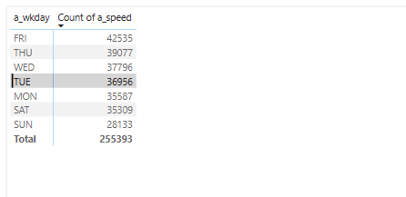

This matrix uses a_wkday as rows and count of a_speed as values, effectively visualising the count collisions occurred each day of the week. Friday (425353) has the highest number of collisions, followed by Thursday and Wednesday. Sunday (28133) has the lowest number. This trend suggests, the traffic conditions of weekdays provoke a higher rate of accidents. Due to this, Friday might be considered more risky for driving. While Sunday likely have less traffic, which eventually results in fewer collisions.

1. Severity Depictions of Speed and Age Group:

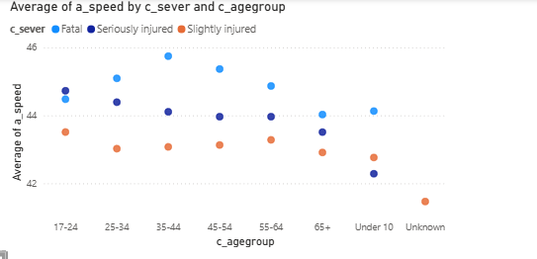

This scatter plot portrays a correlation between average speed and severity types (fatal, seriously injured, slightly injured) for various age groups. There is an increasing count from 17 to 44 age group of people who were involved in fatal injuries because of high speed, which indicates a relationship between fatalities with young people. Victims with minor injuries crash at lower speeds, which suggests that speed has a significant role in the severity of crashes.

1. Gender-Based Collision Analysis:

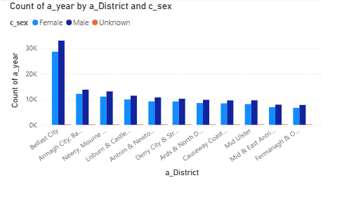

The given bar chart indicates the collision rate in each district based on gender. Here, Belfast City reported the highest number of incidents, possibly due to population density and urban traffic, and Armagh City came second. Moreover, the male drivers are mostly involved in more collisions compared to females in a large number of incidents over almost all districts. Overall, the rate decreases significantly in rural areas like Fermanagh & Omagh.

# NOVELITY

This project brings a new regional perspective to RTCs analysis by integrating PSNI data with customised BI dashboards. This analysis focused on age, place, severity, and speed of the weekday-based trends, unlike the general report on road safety issues. In this study, scatter plots and matrix comparisons provide a more in-depth analysis. Moreover, it proposes a telematics-based pricing system and youth education focusing on local needs.

# DISCUSSION

This result represents cross-national BI methods on transport planning. The ‘Vision Zero’ case in Sweden and the ‘Smart City’ infrastructure illustrate examples of how analytics can impact policy. This approach is generalizable to other regions with comparable datasets and can further be used in predictive modelling by integrating real-time data. However, there was no static historical data with no real-time updates, which caused a barrier during the research. Nevertheless, this study establishes a base for targeted enforcement areas, customising insurance costs by joining the RTC results with data.

# POLICY AND INSURANCE RECOMMENDATION

1. Policy recommendation:

Improve localised infrastructure (such as better lighting and traffic-calming measures), enforce vehicle safety checks, and integrate

road safety education into school curricula to discourage high-risk behaviour.

1. Insurance Recommendation:

Implement fair pricing models that are scientifically evaluated using telematics and behaviour-based assessment, incentives for completing safe driving courses, and cooperate with public agencies for ongoing risk evaluation.

# CONCLUSION

In this research, BI analysis and PSNI data have been effectively utilised to bring out logical insights regarding road traffic collisions in Northern Ireland. High-risk areas, age groups, and risky days were uncovered through visualisation and analysis. This outcome takes action in support of public safety reforms and affordable insurance strategies. In the future, by accessing the telemetrics data input, this framework can develop an interactive risk management predictive real-time system.

# REFERENCES

1. Vision Zero Network, “Vision Zero Network,” *Vision Zero Network*, Apr. 14, 2025. <https://visionzeronetwork.org/>
2. F. Bhatti, M. A. Shah, C. Maple, and S. U. Islam, “A novel Internet of Things-Enabled Accident Detection and Reporting system for smart city environments,” *Sensors*, vol. 19, no. 9, p. 2071, May 2019, doi: 10.3390/s19092071.
3. A. Ziakopoulos, V. Petraki, A. Kontaxi, and G. Yannis, “The transformation of the insurance industry and road safety by driver safety behaviour telematics,” *Case Studies on Transport Policy*, vol. 10, no. 4, pp. 2271–2279, Oct. 2022, doi: 10.1016/j.cstp.2022.10.011.